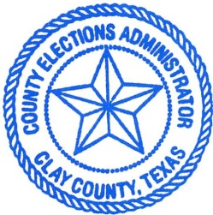
Clay County Elections Integrity: “Kindness to All People All the Time.”
214 N Main Street val.mcclain@co.clay.tx.us
Henrietta, TX 76365 940-264-VOTE

Unofficial Results, Bellevue ISD

Blake Davis 79

John Grunseich 85

Candi Ratliff 20

Mitchell Ford 91

Rob Ratliff 22

